ASSIGNMENT 1 - Solutions

Que.1. Explain the difference between frontend, backend, and full-stack development with
suitable real-world examples.

Sol:- Frontend Development:
Frontend is the part of a website or application that users can see and interact with. It includes the layout, buttons, images, menus, and overall design. Frontend developers mainly use HTML, CSS, and JavaScript.
Example:
When you open Instagram, the posts, stories, and buttons visible on your screen are part of the frontend.

Backend Development:
Backend is the part that works behind the scenes. It handles data processing, user authentication, and communication with the database. Users cannot directly see the backend.
Example:
When you log in to Instagram, the process of checking your username and password is handled by the backend.

Full-Stack Development:
A Full-Stack Developer can work on both the frontend and backend of a website or application.

Example:
A developer who creates the Instagram interface and also manages the login system and database is called a Full-Stack Developer.

Que.2. Create a simple diagram showing how the client-server model works in web architecture.

Sol:- CLIENT(FRONTEND) SERVER(BACKEND)

HTTP REQUEST
------------------------------->>>
HTTP RESPONSE
<<<--------------------------------

Que.3. Describe how a browser requests and displays a web page from a web server.

Sol:- Steps:---->

1. A user enters a website address (URL) in the browser.
2. The browser sends a request to the web server.
3. The server receives the request and finds the required web page.
4. The server sends the web page back to the browser.
5. The browser displays the web page on the screen.

Example:
If you type [www.youtube.com](http://www.youtube.com), the browser asks the YouTube server for the webpage. The server sends the page and the browser shows it on your screen.

Que.4. Identify and list the tools required to set up a web development environment. Explain the
purpose of each.

Sol:- Tools Required to Set Up a Web Development Environment

Tool Purpose
Code Editor (VS Code) Used to write and edit code
Web Browser (Chrome, Firefox) Used to view and test web pages
Programming Languages (HTML, CSS, JavaScript) Used to create the structure, design,
and functionality of websites
Local Server (XAMPP, WAMP) Used to run and test websites on a
computer before deploying them online
Version Control (Git) Helps track code changes and manage projects
GitHub Used to store and share code online
Node.js Allows JavaScript to run outside the browser
and helps install development tools

Que 5:- Explain what a web server is and give examples of commonly used servers.

Sol:- A web server is a software or system that stores website files and sends them to users when they request a web page through a browser.

When a user enters a website address, the browser sends a request to the web server. The web server processes the request and sends the required web page back to the browser.

Common Examples of Web Servers:---->>

  - Apache HTTP Server
2. Nginx
3. Microsoft IIS (Internet Information Services)
4. LiteSpeed

Que 6:- Define the roles of a frontend developer, backend developer, and database administrator
in a project.

Sol:- 1. Frontend Developer

  - Creates the part of the website that users can see and use.
2- Designs web pages, buttons, menus, and layouts.
3- Uses HTML, CSS, and JavaScript.

Example:
The login page and homepage design of a website are created by the frontend developer.

2. Backend Developer

  - Works on the server side of the website.
2- Handles user requests, business logic, and communication with the database.
3- Ensures that the website functions correctly.

Example:
Checking a user's login details and processing data are tasks of the backend developer.

3. Database Administrator

  - Manages and maintains the database.
2- Stores, organizes, and secures data.
3- Ensures data is available and backed up properly.

Example:
Managing user information, passwords, and records in the database

Que 7:- Install VS Code and configure it for HTML, CSS, and JavaScript development. Take a
screenshot of the setup.

Sol:-
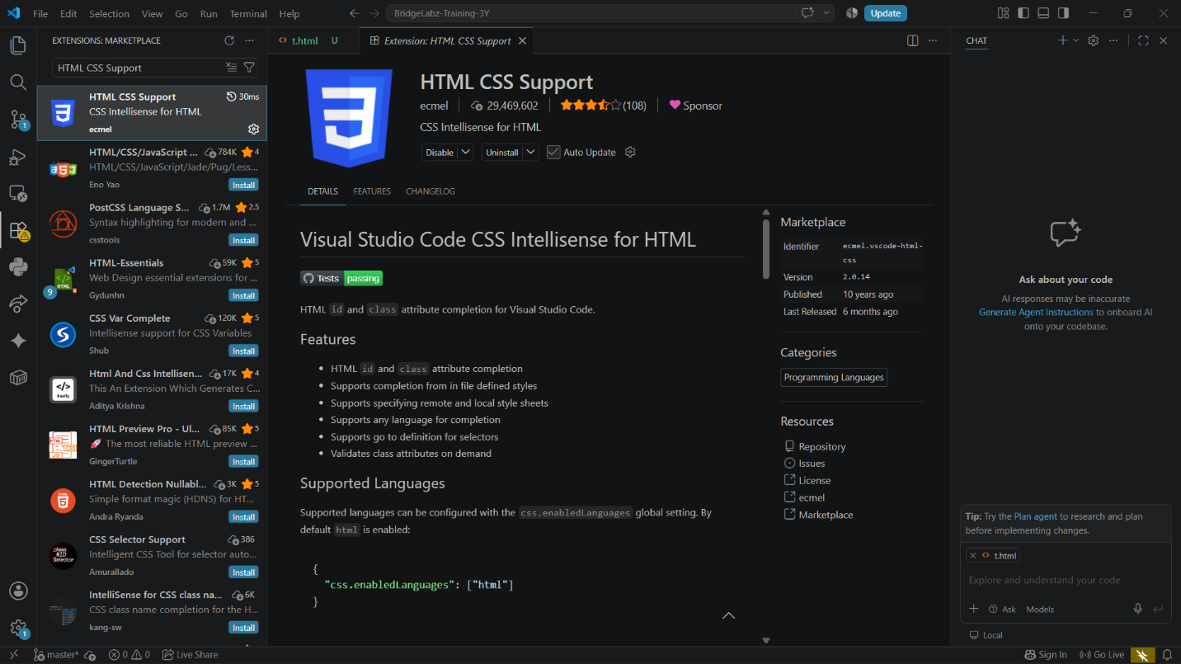
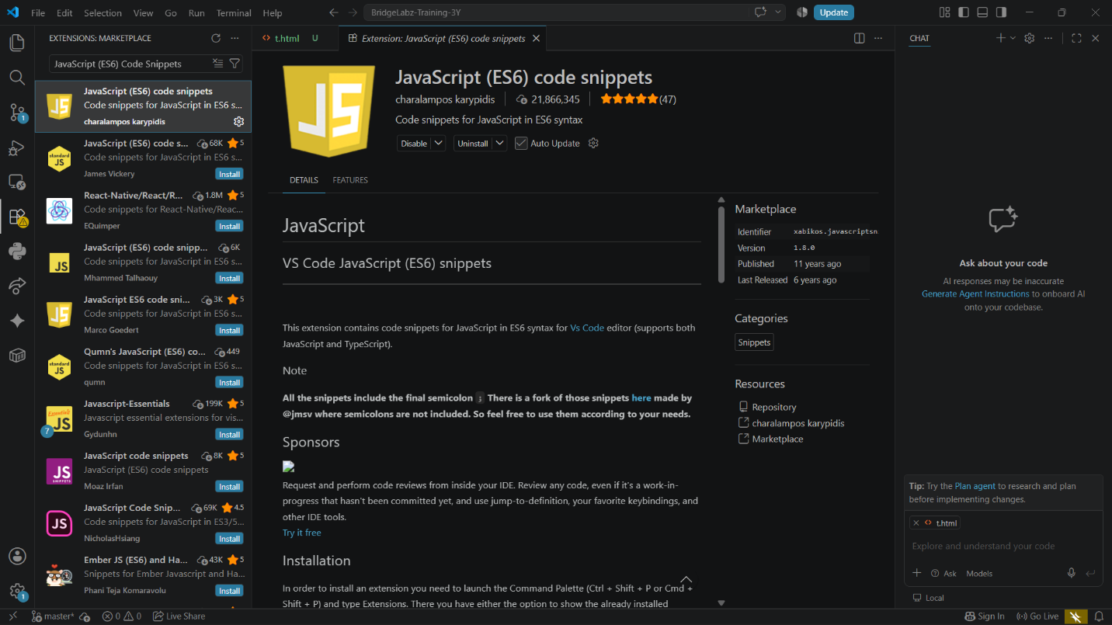

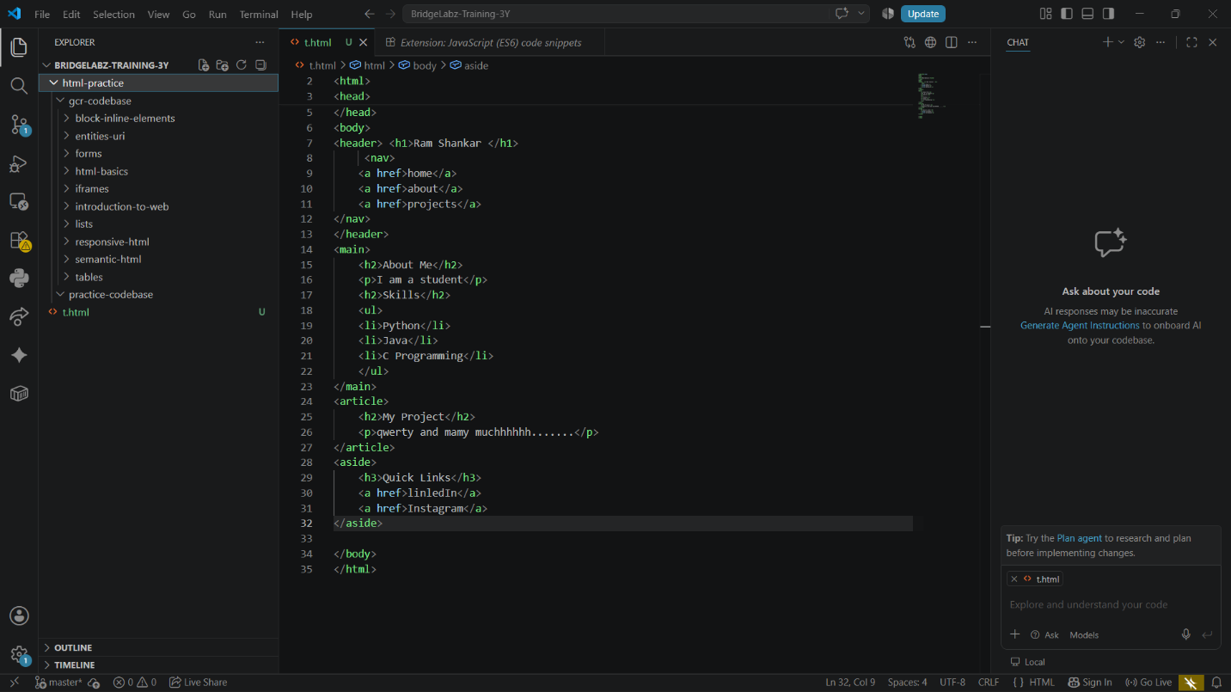

Que 8:- Explain the difference between static and dynamic websites. Provide an example of
each.

Sol:- Static Website:------>>
A static website is a website that shows the same content to all users. The information on the website remains fixed and can only be changed by editing the source code. Static websites are simple, fast, and easy to develop.
Example: A personal portfolio or company information website.

Dynamic Website:-------->>
A dynamic website is a website whose content can change according to the user, time, or data stored in a database. These websites are interactive and can update information automatically. Example: Instagram, Facebook, and Amazon, where different users see different content after logging in.

Que 9:- Research and list five web browsers. Explain how rendering engines differ between
them.

Sol:- Five Web Browsers:

1.Google Chrome
2.Mozilla Firefox
3.Microsoft Edge
4.Safari
5.Opera

A rendering engine is a part of a web browser that converts website code (HTML, CSS, and JavaScript) into the web page that we see on the screen.

Different browsers use different rendering engines. Because of this, the same website may look or work slightly differently in different browsers. Some rendering engines are faster, while others focus more on compatibility or performance.

Que 10:- Draw a labeled diagram showing the basic web architecture flow — client, server,
database, and APIs.

Sol:- Sol:- Basic Web Architecture Flow
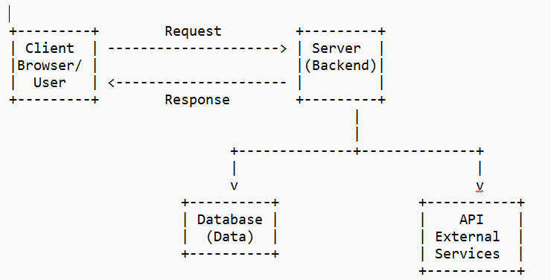

Components:

-> Client: User's browser that sends requests.
-> Server: Processes requests and sends responses.
-> Database: Stores website data.
-> API: Connects the server with external services or applications.

